
https://atlas.cid.harvard.edu/

Optimal Industry Development Strategy Using Economic and Product Complexity

Mexico
─
The Economic Complexity Lab - Columbia University
Haoxian Chen, Davepriyan Gunaratnam, Rohan Macherla, Ajit Akole, Shomik Ghose, Alex Wei-Liang Ku, Sannidhya Modi, Xilin Wang, Alexandra Garcia, Kelly Mi, Alex Chung, Margarita Demkina
Optimal Industry Development Strategy for Mexico

0. Executive Summary

In this report, we aim to uncover the economic path Mexico went through during the period from 2013 to 2021. Specifically, we dive into the topic through a macroeconomic overview of Mexico from the perspective of Gross Domestic Product (GDP) and Economic Complexity Index (ECI), which reflect countries’ production capability and production structure, respectively. We find that during the period of our interest, Mexico demonstrated a an increased level of economic growth with an average annual GDP growth rate of 0.5% between 2013 and 2018 and 1.53% between 2019 and 2021, with a highly volatile economic complexity, especially since the onset of the pandemic compared to other major developed economies.

The mixed progress during the period, we believe, can be partially explained through the analysis of the economic and product complexity structure of Mexico on the industry group level, as well as the improved macro and microeconomic strategies. The product classification system we adopt allows us to measure the realized industry development for various industry groups and to observe that Mexico regressed in developing most of its industries during the period while its developed counterparts and emerging economies around the globe also adopted complex and progressive paths with variable degree of success.

Based on our analysis of the opportunity gain and sensitivity analysis of major industry groups for 2013-2018, Mexico can further its gains by prioritizing Daily Instruments and Chemicals. We further note that Mexico has a well-matched development strategy that indicates a particularly high level of structural optimality on the complexity level, having an adjusted R-square of merely -6.1%, compared to 8.8% in 2021. Since a significant positive correlation exists between five-year GDP growth and the structural optimality index of an economy as we define and calculate, Mexico indeed has a nearly optimal growth experience as compared with fast-growing economies both on a regional and global scales and has the potential to further its economic gains through industrial structure optimization as suggested in the paper.

The three years following showed a significant improvement in Mexico’s economic growth, boosting its position alongside its peers. Its GDP recovered to above the pre-pandemic levels, but it saw a significant decline in the ECI, particularly compared to its peer countries. We also note that Mexico has changed its investment strategy in the sectors identified earlier toward more high-level industries, still leaving some room for strategic improvement in Energy Drilling and Precious, Metals, and Chemicals industries, for instance. Its current strategy still has viable potential upside to increase its performance and optimize its structure further.

1. Report Overview

In this report, we aim to uncover the economic path Mexico went through during the period from 2019 to 2021, before and after the COVID pandemic, compared to its performance from 2013 to 2018. Specifically, we dive into the topic through a macroeconomic overview of Mexico from the perspective of Gross Domestic Product (GDP) and Economic Complexity Index (ECI), which reflect countries’ production capability and production structure, respectively. We then analyze the industrial framework and changes of Mexico during the period based on quantitative measures such as the Product Complexity Index (PCI) and Product Family Complexity Index (PfCI), followed by a detailed analysis of how such changes have matched with development strategies as quantitatively measured by opportunity gains on an industry-level. We conclude our report with macro-level results and predictions of Mexico, as deduced from regression models we have established on a global scale, which take into account countries’ stances in their product space.

2. Macroeconomic Results

2.1 GDP Ranking and Changes
As the 15th largest economy in the world by GDP in 2021, Mexico has a GDP of 1.27 trillion USD in 2013, 1.22 trillion USD in 2018, and 1.29 trillion USD in 2021, exhibiting an steady economic output. Figure 1a illustrates the time-series GDP results for major emerging economies from 1999-2018, and Mexico demonstrates a high level of consistency in terms of both GDP and GDP growth. However, its growth rate is not significant as compared with many other emerging economies in the world, with an average annual growth of 0.5% during the period from 2013 to 2018. This number is much smaller than the annual growth rate of the other five leading emerging economies, which have a geometric average growth rates of 2.2% and an arithmetic average growth rate of 2.4%. The contrast is particularly significant with China, one of the leading emerging economies in the world, which has an average annual growth rate of 8.2% during the same period. The pace of economic growth in Mexico, we believe, can be reflected through changes in ECI and PCI, and can be further explained by a suboptimal set of production strategies adopted by Mexico from 2013 to 2018, which we will expand at the later stage of the report.

Figure 1b shows the GDP levels for Mexico and its peer countries (China, Brazil, Malaysia, South Korea, UAE) from 2019 to 2021. Similar to the other countries, Mexico displayed a drop in GDP from 2019 to 2020 because of the pandemic, with all GDPs rebounding in 2021. Over these three years, Mexico’s average annual GDP growth rate (1.53%) is in the middle of the pack, as it is greater than Brazil’s rate (-3.87%), Malaysia’s (0.95%), and UAE’a (0.55%) but less than South Korea’s (3.00%). It is notable that the GDP levels in Mexico and its comparable countries with the exception of Brazil have rebounded and increased from the pre-pandemic levels.

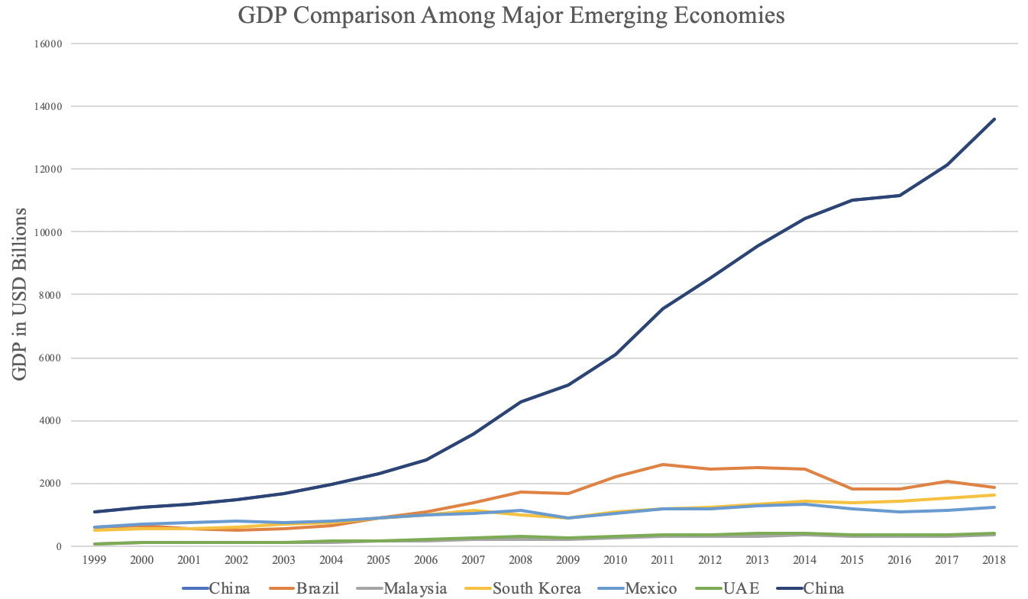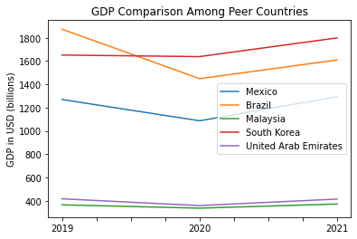
Figures 1a and 1b. GDP Comparison Among Peer Countries (left: 1999-2018; right: 2019-2021)

2.2 ECI Ranking and Changes
The Economic Complexity Index (ECI), as defined by Ricardo Hausmann and Cesar Hidalgo in 2009 is used to explain the knowledge accumulated in a country's population.

As illustrated in Figures 2a and 2b below, Mexico exhibits a huge increase in terms of its production capability from 2013 to 2018, as measured by ECI. This change is similar to countries such as China and South Korea, which demonstrate a steady trend in terms of both the ECI and GDP indexes.

The comparable countries had drastic changes in ECI levels between 2019 and 2020, with a particularly sharp change between 2020 and 2021 as the COVID policies fluctuated across the regions. Mexico exhibits a large decrease in production capability in 2021, erasing the progress from the prior eight years. Mexico has seen a 197% decrease in its ECI, which is much smaller than Brazil’s (252%), Malaysia’s (-180%), and UAE’s (207%) but higher than South Korea’s (-202%).
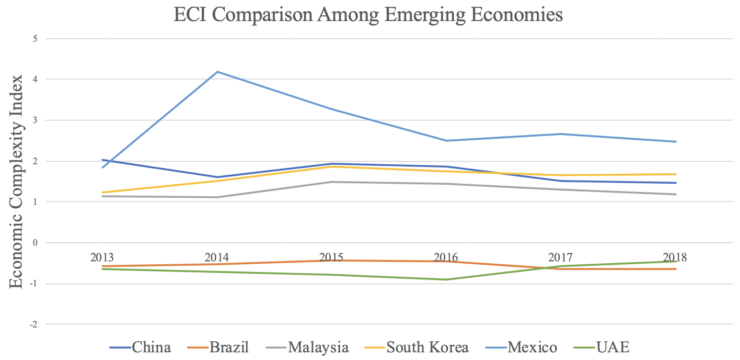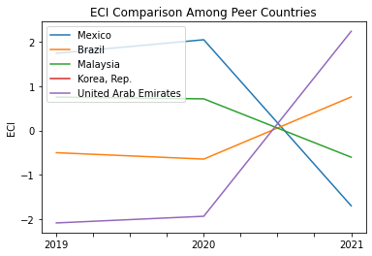
Figures 2a and 2b. ECI Comparison Among Peer Countries (left: 2013-2018; right: 2019-2021)

Figures 3a and 3b offer a further comparison of GDP Growth and ECI from 2013 to 2021 for Mexico. Based on statistical analysis, ECI is a significant covariate for GDP with an adjusted R-square of 33.8% in 2018 and 21.2% in 2021. In particular, the changes in GDP during the period from 2013 to 2018 are consistent with the changes in ECI, indicating great predictive power of ECI in terms of Mexico’s potential economic development. The effectiveness of the country in developing a competitive product space that helps to accumulate complicated knowledge and technology can be reflected by the increase in ECI.

The changes in GDP during the period from 2019 to 2021 differ greatly from the changes in ECI, indicating weak predictive power of ECI in terms of Mexico’s potential economic development. The lack of relationship implies that GDP growth is not consistent with the predictions by ECI and that Mexico could make a stronger progress towards effectively developing a competitive product space that helps to accumulate complicated knowledge and technology. In order to get a better insight of the relationship between ECI and the country’s economy, we will dive into an analysis of Mexico’s production structure and its product space designs in the next few chapters.
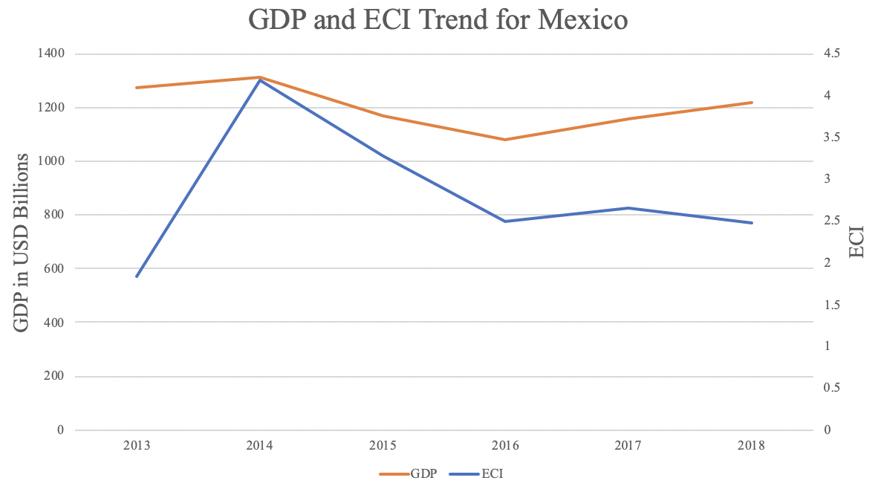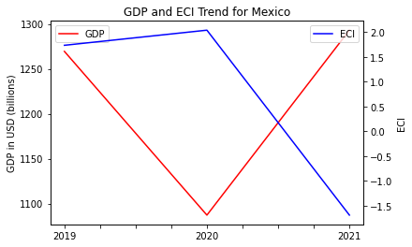
Figures 3a and 3b. GDP Growth and ECI for Mexico (left: 2013-2018; right: 2019-2021)
3. Production Analysis

3.1 Product Categorization
Our main data source in this research is the UN Comtrade Website (https://comtrade.un.org), which provides us with valuable information on countries’ export values on an annual basis, including highly specific export data for more than 5000 categories of products. In order to have a holistic vision of the product space of a country, however, a level of categorization is required. Products in our data source are labeled from 010000-999999, with the first two digits representing a general category to which the product belongs. Based on the 99 categories extracted from the label, we further group the products into the 18 most widely-accepted industries, as summarized in Table 1.

Note that the High-complexity Products industry group is not a distinct industry but rather an aggregated industry that encompasses the most complicated products from the most technologically-advanced industries (as measured by PCI). This industry serves as an indicator for us to quantitatively evaluate how well a country has performed in developing cutting-edge technologies and closing its technological gap with advanced economies, which has become a topic of wide concern today. Indeed, when we rank the 18 categories based on PfCI (an equivalent concept of PCI as calculated based on the 18 categorized product groups), the High-complexity Products industry has the highest PfCI among all industry groups.

Category | Description
Animals and By-products | All kinds of meat, livestock and related by-products
Vegetables, Fruits and Plants | All kinds of plants, edible vegetables and fruits
Food and Preparations | Edible preparations, raw cooking materials and appliances
Clothing and Accessories | All kinds of fabrics, filament, clothing and accessories
Textiles | All kinds of textile articles and related products
Wood Products | Book, paper and other elementary products related to wood
Metals | Mining of all sorts of raw Metals
Refined and Processed Stones | Refined or processed stone products such as pearl and ceramics
Energy Drilling and Mining | Mining industry for energy, minerals, stone materials, etc.
Daily Instruments | Basic daily instruments such as sport requisites, timing and measuring tools
Raw Manufacturing | Basic products made from plastic, rubber, leather, etc.
Chemical Manufacturing | Advanced chemical products and pharmaceutical products
Chemicals | Raw chemical materials and by-products
Machinery and Construction | Machinery and mechanical appliances, including electrical equipment
Transportation | Vehicles and locomotives including aircraft, ship, railway, etc.
Weapons | Explosives, arms and ammunition
Services and Utilities | Financial, business, legal, communication, travel Services and Utilities, etc.
High-complexity Products | Agglomeration of advanced products with highest PCIs
Table 1. Categorization of Products

We further observe a positive correlation between the GDP and the export of High-complexity Products. A higher adjusted R-square exists between GDP and High-complexity Products exports, indicating that more successful economics, as measured by GDP, tend to be those that are capable of producing and exporting High-complexity Products as we define them. Tables 2a and 2b show the OLS results in a universe of 107 and 21 typical countries respectively.
 | High-complexity Products | Food and Preparations | Animals and By-products
Adj. R-squared | 0.075 | 0.006 | 0.002
F-statistic | 9.556 | 1.638 | 1.175
No. Observations | 107 | 107 | 107
Table 2a. OLS Regression Results of GDP against Percentage Volume of Exports

 | High-complexity Products | Food and Preparations | Animals and By-products
Adj. R-squared | 0.149 | 0.003 | -0.012
F-statistic | 4.510 | 1.059 | 0.7542
No. Observations | 21 | 21 | 21
Table 2b. OLS Regression Results of GDP against Volume of Percentage Exports

3.2 Realized Industry Development
Based on the aforementioned product categorization, we aim to capture Mexico’s realized industry production strategy between 2013 and 2021 on a complexity level. In Hausmann and Hidalgo (2009), distance is defined to be a measure of how far a country is from a certain product, not in its product space. We extend this concept to all product groups and quantify how technically equipped a country is to develop the corresponding product groups. In other words, the shorter the distance between a country and a product group, the more capable a country is of developing products within that group. Defining this net distance change as the Realized Industry Development (RID), our export data allow us to calculate and compare the RID of Mexico and the 18 product groups in 2021 and 2018 through the difference, where a positive RID indicates a shortening of the distance (i.e., advancement of the industry), and a negative RID indicates the reverse. As shown in Table 3, during the periods ending in 2018 and 2021, Mexico has focused on products with a moderate level of complexity and those requiring intermediate skills, like Transportation and Services and Utilities. It is notable that the number of industries with positive RID has increased from 2 to 15 from 2018 to 2021.

Category | RID (2021) | RID (2018)
Chemicals | -0.009 | 0.002
Daily Instruments | -0.008 | -0.041
Machinery and Construction | -0.007 | -0.028
High-complexity Products | 0.003 | -0.048
Energy Drilling and Mining | 0.004 | -0.006
Metals | 0.007 | -0.018
Clothing and Accessories | 0.008 | -0.025
Services and Utilities | 0.009 | -0.05
Transportation | 0.012 | -0.057
Raw Manufacturing | 0.014 | -0.011
Wood Products | 0.015 | -0.007
Food and Preparations | 0.017 | -0.006
Textile | 0.018 | -0.016
Animals and By-products | 0.020 | -0.005
Chemical Manufacturing | 0.022 | -0.025
Vegetables, Fruits and Plants | 0.025 | -0.014
Precious Stones | 0.051 | -0.042
Weapons | 0.068 | 0.002
Table 3. Realized Industry Development (RID) of Mexico

3.3 Regional and Global Comparison
Tables 4a and 4b below summarize how the production strategy adopted by Mexico compares with selected leading economies in the world across different years, as measured in RID. It can be directly observed that Mexico shifted its focus from products with a lower complexity level in 2018 to more specialized industries (such as Chemicals, Daily Instruments, and Machinery and Construction) in 2021, when compared against leading economies such as France, the United States and Germany, which gave a considerable level of attention to more advanced product groups such as Weapons and High-Complexity Products in 2018 and Services and Utiliteis, Precious Stones, and High-Complexity Products in 2021.

Ranking | France | the UK | Germany
1 | High-complexity Products | Services and Utilities | High-complexity Products
2 | Chemical Manufacturing | Weapons | Transportation
3 | Daily Instruments | Raw Manufacturing | Wood Products
4 | Animals and By-products | Precious Stones | Metals
5 | Food and Preparations | Animals and By-products | Food and Preparations
Table 4a. RID Comparison across Leading Economies (2018)

Ranking | France | the UK | Germany
1 | Services and Utilities | Precious Stones | Daily Instruments
2 | Precious Stones | High-complexity Products | Transportation
3 | High-complexity Products | Services and Utilities | Chemicals
4 | Energy Drilling and Mining | Energy Drilling and Mining | Chemical Manufacturing
5 | Machinery and Construction | Wood Products | Clothing and Accessories
Table 4b. RID Comparison across Leading Economies (2021)

Tables 4c and 4d further examine Mexico’s development strategy against those of emerging economies on a global scale. Reasonably, emerging economies such as China, South Korea, and Singapore, have devoted the majority of their efforts to intermediate industry groups, showing drastic shifts in strategies over the course of three years. Economies similar to Mexico should have relied more on advanced industry groups - the shift in focus visible from 2018 to 2021. This trend holds true in general, regardless of the continent or the time period, and serves as an indicator for which phase of development a country is currently in as evaluated from its production strategy. Based on this standard, Mexico is indeed adopting a moderate but slightly out-of-phase strategy that seeks development in industry groups with a lower level of complexity than it should.

Ranking | China | South Korea | Singapore
1 | High-complexity Products | Transportation | Transportation
2 | Transportation | Textile | High-complexity Products
3 | Machinery and Construction | High-complexity Products | Precious Stones
4 | Energy Drilling and Mining | Chemical Manufacturing | Daily Instruments
5 | Daily Instruments | Machinery and Construction | Services and Utilities
Table 4c. RID Comparison across Emerging Economies (2018)

Ranking | China | South Korea | Singapore
1 | Chemicals | Chemicals | Weapons
2 | Daily Instruments | Daily Instruments | Energy Drilling and Mining
3 | Transportation | Transportation | Transportation
4 | Raw Manufacturing | Textile | Machinery and Construction
5 | Weapons | Raw Manufacturing | High-complexity Products
Table 4d. RID Comparison across Emerging Economies (2021)

4. Product Space Design

4.1 Suggested Development Vector
As outlined above, distance gives us an idea of how far each new product is from a country’s current mix of exports. As defined in Hausmann and Hidalgo (2009), distance is “the weighted proportion of products connected to goods $p$ that country c is not exporting, i.e., MCP=0.” Based on this definition, the distance between a country and any product that the country is currently exporting (i.e., the country is a significant exporter of the product as compared to the global average) is zero. Similarly, opportunity gain quantifies the contribution of a new product in terms of opening up the doors to more and more complex products. Intuitively, a product that a country is currently exporting (i.e., MCP=1) has an opportunity gain of zero. An unreasonable investment in a certain product $p$ would lead to a relative decrement in the export of more profitable products and therefore lead to a negative opportunity gain of product p. The opportunity gain is not the only estimator of a country’s level of economic development. However, among countries with comparable economic strength, those having higher ECI, or in other words, more reasonable economic structures are often in better shape.
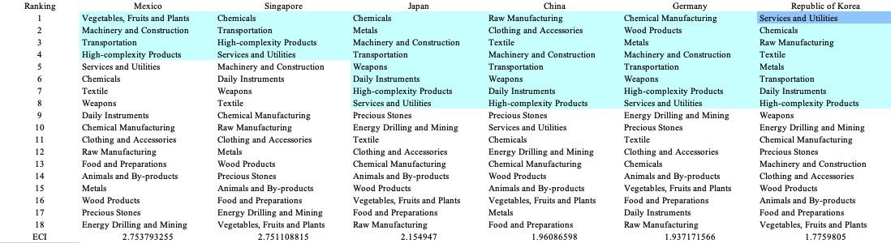
Table 5a. SDV of High ECI Countries (2013)

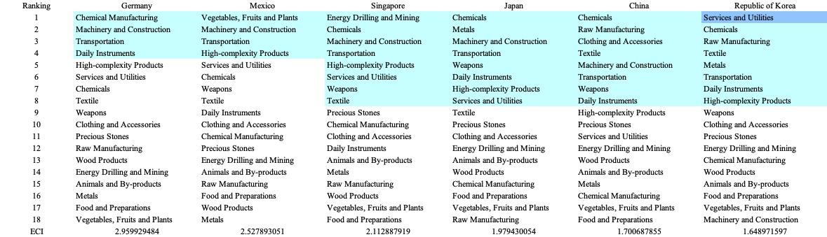
Table 5b. SDV of High ECI Countries (2018)

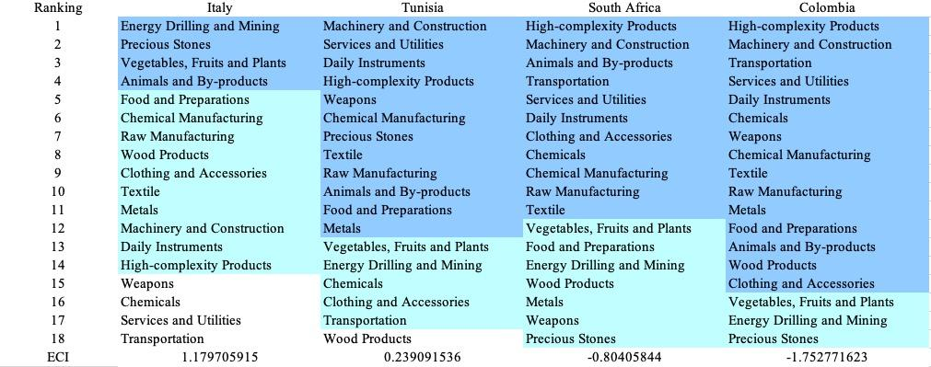
Table 5c. SDV of Other Sample Countries (2013)

We define the ranking of opportunity gain for a country c, as the Suggested Development Vector (SDV) of c. Tables 5a-5d summarize how the SDV of Mexico compares with a selected group of comparable and leading economies in the world, with the industry groups ranked in decreasing order of significance. We focus on SDV results for 2018 because they give the most accurate snapshot of complexity for global comparison in the absence of the irregular effects of the COVID-19 pandemic observed in 2021.

Dark blue indicates positive opportunity gains, light blue indicates zero opportunity gains, and white indicates negative opportunity gains. The result shows that leading countries barely have any industries with positive opportunity gain. In other words, those countries are already in the most stable and efficient economic structure. Without the necessity of economic transition, those countries merely need to maintain a steady and balanced economic development. In contrast, developing countries have nearly half of industries with positive opportunity gain and share common interests in industrial manufacturing and High-complexity Products industries. It can be concluded that Mexico shares the characteristics of leading countries, with a balanced economic structure that leans towards intermediate and high-level industries.


Table 5d. SDV of Other Sample Countries (2019)
4.2 Budgeted Industry Development Strategy and Interpretation

The optimal budgeted industry development strategy aims to solve the most efficient allocations under the budgeted constraint of different situations of heuristic total export growth. In order to obtain such an allocation portfolio, we formulate an optimization problem as the following:



where k(x) is the second largest eigenvector of $M_{CC'}$ after adding $x$ to the original export vector, C is the country that we are interested in, P is the product space, B is the heuristic budget.

If we can solve this problem, then we can know what the largest ECI to which a country can improve. Accordingly, the optimal solution $x*$ that we obtain here is exactly our optimal allocation. However, the biggest problem is that the objective function is not convex. Therefore, we cannot apply the classical tools for convex optimization to this problem. In order to solve this problem, our idea is to use a greedy algorithm. The way that we apply the greedy algorithm is that firstly we separate the total budget into k equal parts, and then for the first equal part we try to search for the product that can optimize our objective function by iterating through each $p∈P$. After we find the optimal product p for this equal part, we add the amount back to the export value of this product p and update the ECI for this country. If we observe that ECI does not change after iterating all the products, then we can add up one more equal part to invest. Until we find there is an ECI increment, we add the amount now to that product. The equal rest parts can be done in the same way.

By definition, a greedy algorithm is a kind of local search algorithm that is possible to run into a local minimum. Therefore, for local search algorithms, one typical way to keep it away from the local minimum is to enhance the vision of the algorithm by looking more steps forward. In our setting, whenever we obtain an increment of ECI, we mark down the required amount of export growth. Simultaneously, we continue searching for the next ECI increment point, compare the ratios of these two possibilities and pick the largest one. The ratio is defined as the following:

where ${ECI}_{p}$ is just the ECI of the country after adding some amount of export increment to product $p$, which is exactly the amount that is able to make ECI change. Also, we can express it in the way of $||$$x_{p}-x_{0}$${||}_{1}$.In this way, we can obtain a further sighted greedy algorithm. Also, the number of parts that we would like to separate the budget into also matters. In order to solve this problem, we added a stabilizer on top of the enhanced greedy algorithm by running the algorithm for different numbers of parts and selecting the portfolio with the largest ECI increment and most complex economic structure.

Besides, it is quite common that there is a surplus in the budget. To deal with the surplus, we just add it to the product which needs the least amount of dollars to make $M_{cp}$ = 1 (i.e., the smallest amount of required export increase).

Economic Panel:

As stated above, the enhanced greedy algorithm is developed mainly for solving the optimal allocation strategy. In order to visualize this allocation, an economic panel is created consisting of a pie chart, a line chart, and a table. First, a pie chart is used to show the percentage of each product in the optimal portfolio. The number located in the center of the circle denotes the heuristic growth of total export, which is also our budget. Each category in the chart has a determined percentage of the allocated budget. The lines below the pie charts show how the ECI changes during the search process of the greedy algorithm. Even though sometimes an increase in the export by 15% or 20% does not seem reasonable to developed countries, it can also give a sense of how a country should develop in the long term. Eventually, the graph, in the end, is just for a numerical explanation for the pie charts.

Interpretation:

For the purpose of a clear explanation of the line charts, we label all the products in Table 6. Please refer to this table when trying to understand the investment trajectories in the line charts.
Label | Product Names
1 | Animal and By-products
2 | Vegetables, Fruits and Plants
3 | Food and Preparations
4 | Energy Drilling and Mining
5 | Chemicals
6 | Chemical Manufacturing
7 | Raw Manufacturing
8 | Wood Products
9 | Clothing and Accessories
10 | Textile
11 | Metals
12 | Machinery and Construction
13 | Transportation
14 | Weapons
15 | Daily Instruments
16 | Precious Stones
17 | High-complexity Products
18 | Services and Utilities
Table 6. Products Labeling
Figures 4a-4c show an economic panel for Mexico in 2013, 2018, and 2021. We can see that for different percentages of heuristic total export growth, the ECI of Mexico will have a different amount of increments. From the graphs, we see that Mexico already obtains some great increment in terms of ECI, but eventually, the ECIs are not so much different in the pre-pandemic years, after which it drops. This trend means that in terms of export, Mexico has already achieved a well-balanced stage. In 2013, in the case of 5 and 10 percent increments, precious stones is the only product that can boost the ECI optimally. For the case of 15 and 20 percent increments, the ECI does not change a lot, but there are still some tiny gains by increasing the export of Machinery and Chemicals. However, the additional investment in these industries offers a small amount of ECI gains. Therefore, under-budgeted constraints, the growth of the export of Precious Stones can optimize the ECI. A more detailed numerical representation of the portfolio is shown in Table 7a.

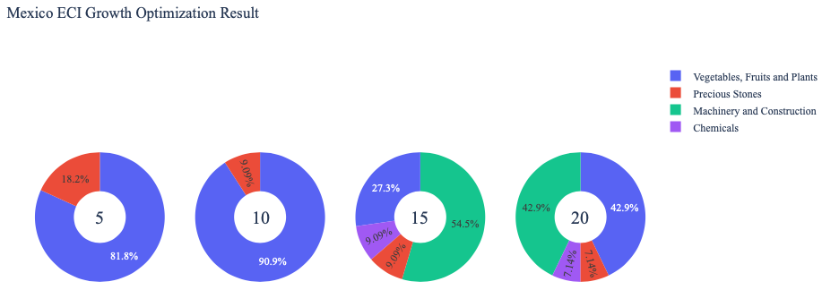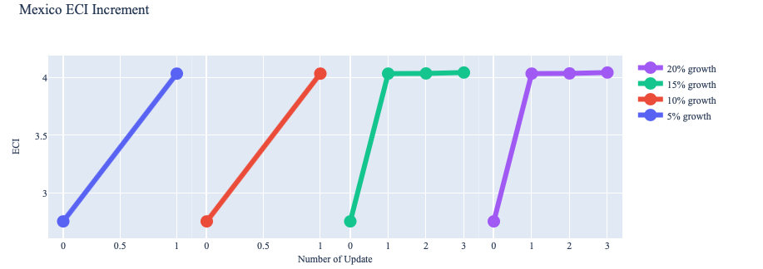
Figure 4a. Greedy-Based ECI Improvement Results of Mexico with Different Budgets (2013)

Mexico (2013)
Original ECI | 2.754
Heuristic Export Growth (%) | 5% | 10% | 15% | 20%
Heuristic Export Growth (USD) | 3.00E+10 | 6.01E+10 | 9.01E+10 | 1.20E+11
Machinery and Construction | 0.00E+00 | 0.00E+00 | 4.92E+10 | 5.15E+10
Precious Stones | 5.46E+09 | 5.46E+09 | 8.19E+09 | 8.58E+09
Chemicals | 0.00E+00 | 0.00E+00 | 8.19E+09 | 8.58E+09
Vegetables, Fruits, and Plants | 2.46E+10 | 5.46E+10 | 2.46E+10 | 5.15E+10
Increased ECI | 4.035 | 4.035 | 4.044 | 4.044
Table 7a. Portfolio of Mexico (2013)
For further suggestions on Mexico’s development in the future, we also offer the optimization result of Mexico based on export data in 2018. Below is the economic panel for Mexico in 2018. We can see that for different percentages of heuristic total export growth, the ECI growth pattern of Mexico is tiny for a 5 percent export growth budget but relatively large for 10 percent or more. For the case of 5, some fundamental products stimulate only a small amount of ECI increment, including daily instruments, chemicals, etc. For the case of 10, 15, and 20 percent growth, their ECIs are not so much different, meaning that the economic complexity structure is pretty well-rounded. However, the products that caused the growth are different. These products are Machinery and Construction, High-complexity Products, and Transportation, respectively for 10, 15, and 20 growth situations. Therefore, for optimal future strategy, Mexico should select one of these three industries to prioritize and then develop Chemicals and Chemical Manufacturing. A more detailed numerical representation of the portfolio is shown in Table 7b.

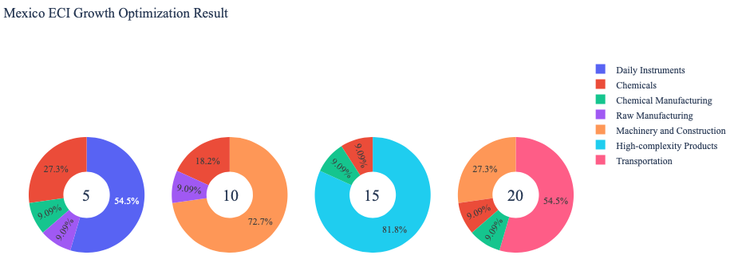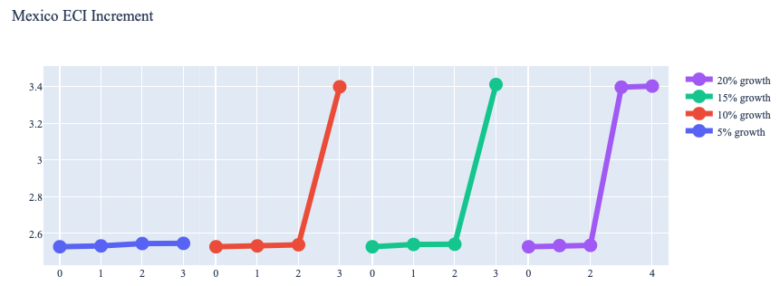
Figure 4b. Greedy-Based ECI Improvement Results of Mexico with Different Budgets (2018)

Mexico (2018)
Original ECI | 2.53
Heuristic Export Growth (%) | 5% | 10% | 15% | 20%
Heuristic Export Growth (USD) | 3.62E+10 | 7.23E+10 | 1.01E+11 | 1.45E+11
Chemicals | 9.86E+09 | 1.31E+10 | 9.86E+09 | 1.31E+10
Chemical Manufacturing | 3.29E+09 | 0.00E+00 | 9.86E+09 | 1.31E+10
Raw Manufacturing | 3.29E+09 | 6.57E+09 | 0.00E+00 | 0.00E+00
Machinery and Construction | 0.00E+00 | 5.26E+10 | 0.00E+00 | 3.94E+10
Transportation | 0.00E+00 | 0.00E+00 | 0.00E+00 | 7.89E+10
Daily Instruments | 1.97E+10 | 0.00E+00 | 0.00E+00 | 0.00E+00
High-complexity Products | 0.00E+00 | 0.00E+00 | 8.87E+10 | 0.00E+00
Increased ECI | 2.55 | 3.40 | 3.41 | 3.41
Table 7b. Portfolio of Mexico (2018)

To compare with the performance in 2013 and 2018, we also re-examine suggested strategies for 2021. For 2021, a 5 percent increase in export would emphasize Textiles, followed by Weapons, and Animals and By-Products. A 10 and 15 percent growth both emphasize Precious Stones, followed by Textiles for 10 percent and Vegetables, Fruits, and Plants for 15 percent. A 20 percent growth would require an emphasis on the Textile industry again, followed by Precious Stones. These strategies go in line with the suggested trajectories based on ECI. A slight boost in ECI comes from the export growths at different levels, which differs significantly from the portfolios in 2013 and 2018 with the industries in focus such as Daily Instruments, and Machinery and Construction, with the exception of Vegetables, Fruits, and Plants in 2013. A more detailed numerical representation of the portfolio for Mexico is shown in Table 7c.
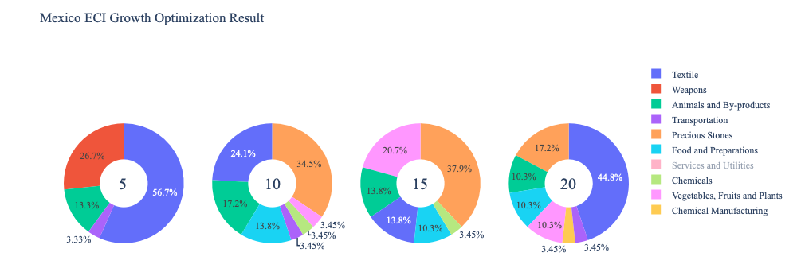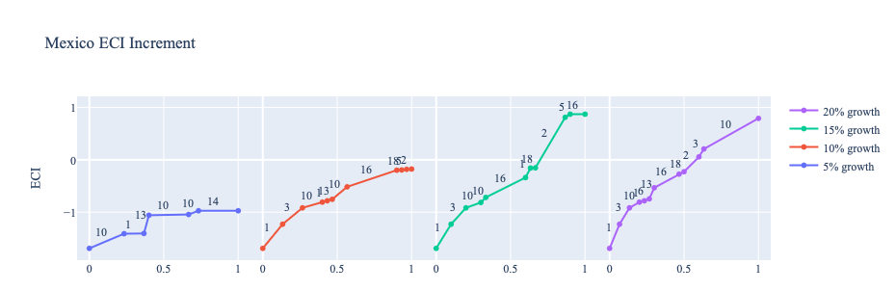
Figure 4c. Greedy-Based ECI Improvement Results of Mexico with Different Budgets (2021)
Mexico (2021)
Original ECI | -1.69
Heuristic Export Growth | 5% | 10% | 15% | 20%
Animals and By-products | 7.29E+09 | 1.12E+10 | 2.14E+10 | 1.61E+10
Vegetables, Fruits and Plants | 0.00E+00 | 2.23E+09 | 3.22E+10 | 1.61E+10
Food and Preparations | 0.00E+00 | 8.93E+09 | 1.61E+10 | 1.61E+10
Chemicals | 0.00E+00 | 2.23E+09 | 5.36E+09 | 0.00E+00
Chemical Manufacturing | 0.00E+00 | 0.00E+00 | 0.00E+00 | 5.36E+09
Textile | 3.10E+10 | 1.56E+10 | 2.14E+10 | 6.97E+10
Transportation | 1.82E+09 | 2.23E+09 | 0.00E+00 | 5.36E+09
Weapons | 1.46E+10 | 0.00E+00 | 0.00E+00 | 0.00E+00
Precious Stones | 0.00E+00 | 2.23E+10 | 5.89E+10 | 2.68E+10
Services and Utilities | 0.00E+00 | 2.23E+09 | 5.36E+09 | 5.36E+09
Increased ECI | -0.97 | -0.18 | 0.87 | 0.79
Table 7c. Portfolio of Mexico (2021)

4.3 Sensitivity Analysis and Contingency Strategy
In the following section our broad aim is to understand how sensitive Mexico is to changes in export in various industries. While the Economic Complexity Index has been shown to contain valuable information about the economic strength/capacity of a country, little has been said as to the stability of the measure itself. We seek to uncover the main drivers of stability under a country's ECI score and better understand longer-term projections for ECI growth. Additionally, gaining an intuition on the industries that are bolstering an economy and the industries that offer the greatest return per unit of investment is best done through visualization of industry-specific sensitivity. To this end, we have developed two categories of sensitivity analysis.
ECI Sensitivity Graph
First, in order to assess the effect particular industries have on each respective country, we developed ECI Sensitivity graphs (Figure 5). We use the shocking methodology to increment or decrement an industry’s export level by a certain percentage and recalculate the ECI all else being equal. While freezing the export dynamics of the rest of the world and enacting an instantaneous shock in export for a particular industry and country may not reflect real-life dynamics, what it does offer us is an understanding of a country’s level of dependency on an industry in the context of ECI. The shocking is done in small percentage increments in order to smooth out the resulting curve. Additionally, a recurring theme one will see is that for most industries, a breaking point occurs where the ECI either jumps upwards or downwards, creating a hockey stick shape rather than a linear trend. While the inflection point may not be accurate in the context of real life, comparing the various inflection points across industries can give us valuable insight.

Figure 5. Sample ECI Sensitivity Graph (2018)
The graphs are formulated as follows. There are six ECI Sensitivity graphs, two for each of the following years: 2021, 2018, and 2013. The first chart, Incremental ECI Sensitivity, shows positive shocking in which export numbers are shocked upwards per industry. The X-axis is in terms of percentage shock per current dollar value of export. The Y-axis is the recalculated ECI level post-shocking. The second chart, Decremental ECI Sensitivity, follows the same format except the X-axis represents negative shock. In other words, exports for each industry are decremented, and the ECI is accordingly recomputed.
SDV sensitivity
Secondly, we analyze the sensitivity of the SDV to changes in export levels. The goal is to understand how export level changes for a particular industry can affect the marginal opportunity gain for other industries. We will be using specifically High Complexity Products and Food and Preparations as our base industries. We will be increasing or decreasing the absolute export level in both of these industries and observing the effects on the SDV.
When the opportunity gain of an industry is negative, the SDV sensitivity approximates how an over-development of the industry jeopardizes the economic structure of a country. When the opportunity gain of the industry is zero, the SDV sensitivity determines whether the further development of the industry shapes the country with a better economic structure and predicts how the SDV would change accordingly. Specifically, as we reduce the export of such an industry to 25%-50% of its original value, a few other industries originally with negative opportunity gain could likely become profitable.
Similar to the ECI sensitivity graphs above, we will be shocking the export of High Complexity Products and Food and Preparations in small percentage increments. A new SDV, represented by a new column in the charts, is recorded only when a certain level of shock changes the structure of the SDV. In effect, we are incrementing or decrementing export levels of two industries until the marginal opportunity gain of any industry changes in category (positive, negative, or neutral). Below is an example of an SDV Sensitivity chart with Positive Shocking. Industries with positive marginal opportunity gain are colored blue, neutral is colored white, and negative is colored red.


Table 9. Sample Incremental SDV Sensitivity for High-Complexity Products (2018)

Contingency Plan
The Contingency Plan aims to present a set of solutions with respect to upheavals in different industries. Instead of compensating for the declining production directly, the best strategy is to develop those incipiently profitable industries. In this manner, we can derive a contingency strategy for countries to deal with possible abrupt declines of crucial industries. In some cases, the SDV remains unchanged even when a zero-opportunity-gain industry declines to 20% in terms of export. We can then conclude the industry is not indispensable to the country. As a clarification, the three consecutive N/As mean that the country doesn’t even need to respond to a collapse in the industry. Countries tend to have distinct solutions to the ups and downs of the same industry. To create the contingency strategy table, we decrease the export level for each industry in the country’s current production space by 60% respectively. The three highest-ranking industries in the new SDV are then returned.

Product Names | 0 | 1 | 2
Animal and By-products | Services and Utilities | Daily Instruments | Weapons
Vegetables, Fruits and Plants | Services and Utilities | Daily Instruments | Weapons
Food and Preparations | Services and Utilities | Daily Instruments | Weapons
Energy Drilling and Mining | Services and Utilities | Daily Instruments | Weapons
Chemicals | Services and Utilities | Daily Instruments | Weapons
Chemical Manufacturing | Services and Utilities | Daily Instruments | Weapons
Raw Manufacturing | Services and Utilities | Daily Instruments | Weapons
Wood Products | Services and Utilities | Daily Instruments | Weapons
Clothing and Accessories | Services and Utilities | Daily Instruments | Weapons
Textile | Services and Utilities | Daily Instruments | Weapons
Metals | Services and Utilities | Daily Instruments | Weapons
Machinery and Constructions | Services and Utilities | Daily Instruments | Weapons
Transportation | Services and Utilities | Raw Manufacturing | Daily Instruments
Weapons | Services and Utilities | Daily Instruments | Transportation
Daily Instruments | Services and Utilities | Weapons | Transportation
Precious Stones | Services and Utilities | Daily Instruments | Weapons
Daily Instruments | Services and Utilities | Daily Instruments | Weapons
Services and Utilities | Daily Instruments | Weapons | Transportation
Table 10. Sample Contingency Strategy (2019)

4.3 Sensitivity Analysis Results and Interpretation

We examine Mexico’s ECI Decremental and Incremental Sensitivity Charts for 2021. An increase in High-Complexity Products and Food Preparations will lead to the highest change in ECI, overlapping with the increased export growth analysis and demonstrating the shift toward the need to develop more high-level industries. The strong sensitivity effect of manipulating the Raw Manufacturing category which was present in 2018 and 2013 is no longer present in the 2021 analysis. For the negative shock cases, Vegetables, Fruits, and Plants stand out as the industry that, if decreased, will lead to big improvements in ECI become most impactful, a similar trend across the data from the three years. The rest of the industries do not appear to have the same level of sensitivity.
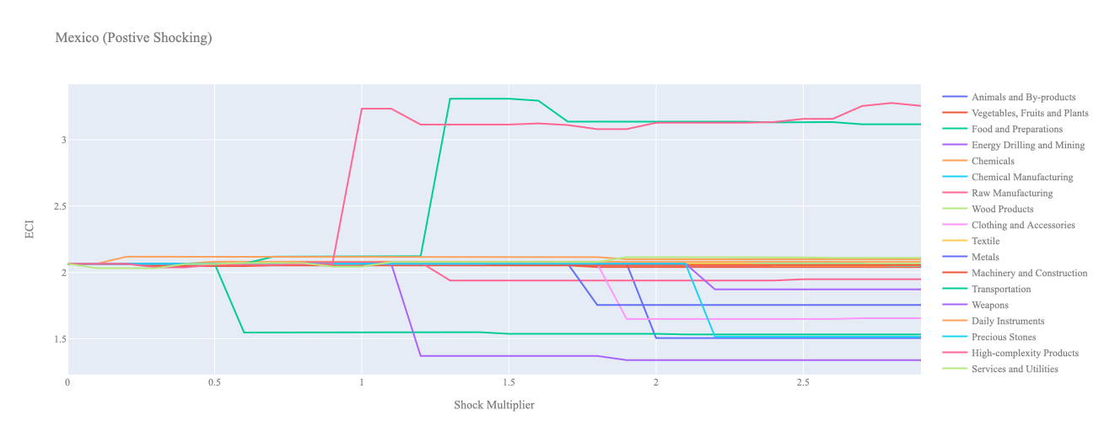

Figure 6a. Incremental ECI Sensitivity for Mexico (2021)
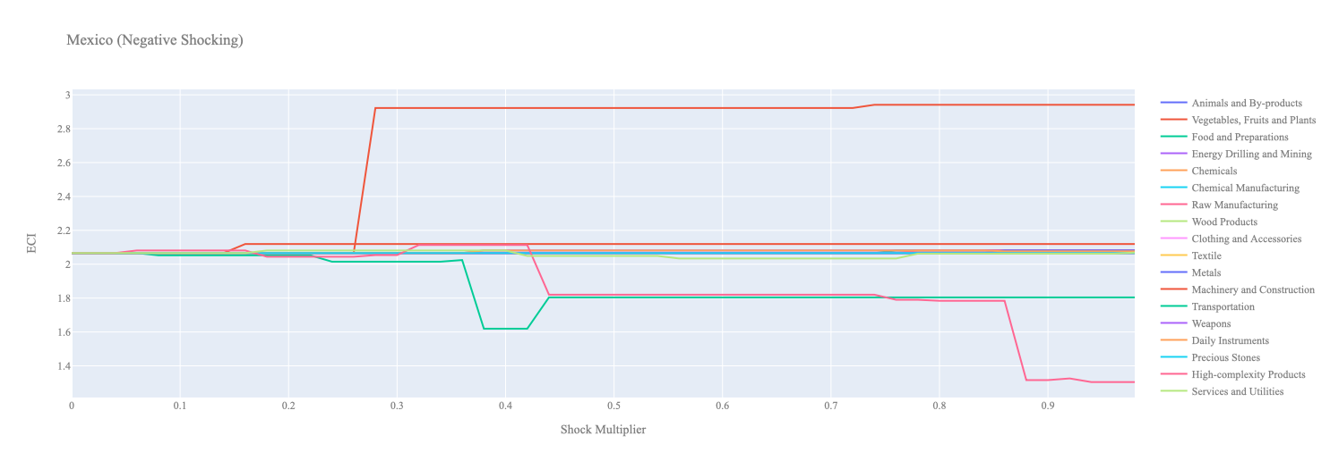
Figure 6b. Decremental ECI Sensitivity for Mexico (2021)
Below is Mexico’s 2018 ECI Sensitivity Charts. Firstly in the positive chart, we notice immediately that High Complexity Products, Transportation and Machinery give fairly significant increases in ECI with only a 15-50% increase net export value. Services and Utilities, as well as Daily Instrument also lead to larger ECI levels however over 100% increase in exports are needed in order to experience the ECI expansion. All other industries tend to not greatly affect the ECI level making it fairly clear which industries to pursue.

Next we consider Mexico’s 2018 Negative Shock chart. We can see that Mexico is fairly sensitive to the three industries listed above as expected from a country that relies on these industries to bolster its ECI level. Interestingly, even small decreases in export of Vegetables, Fruits and Plants can lead to vast increases in ECI suggesting that this industry is not worthwhile for the Mexican economy in the ECI context.

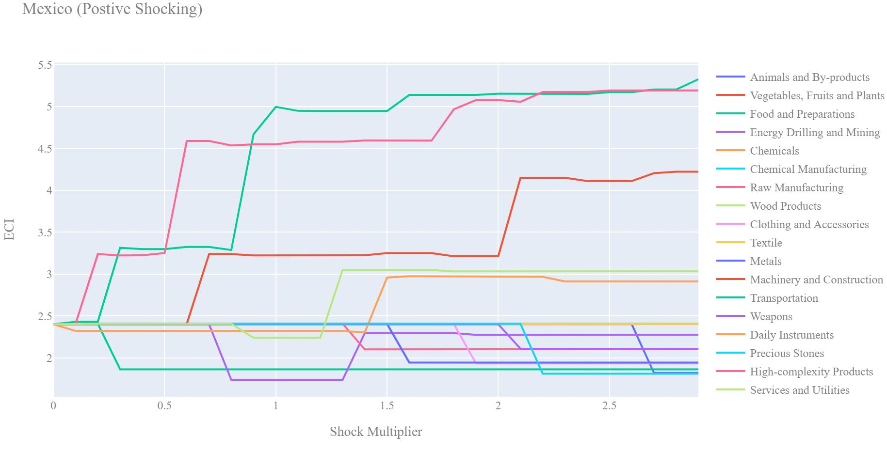
Figure 7a. Incremental ECI Sensitivity for Mexico (2018)

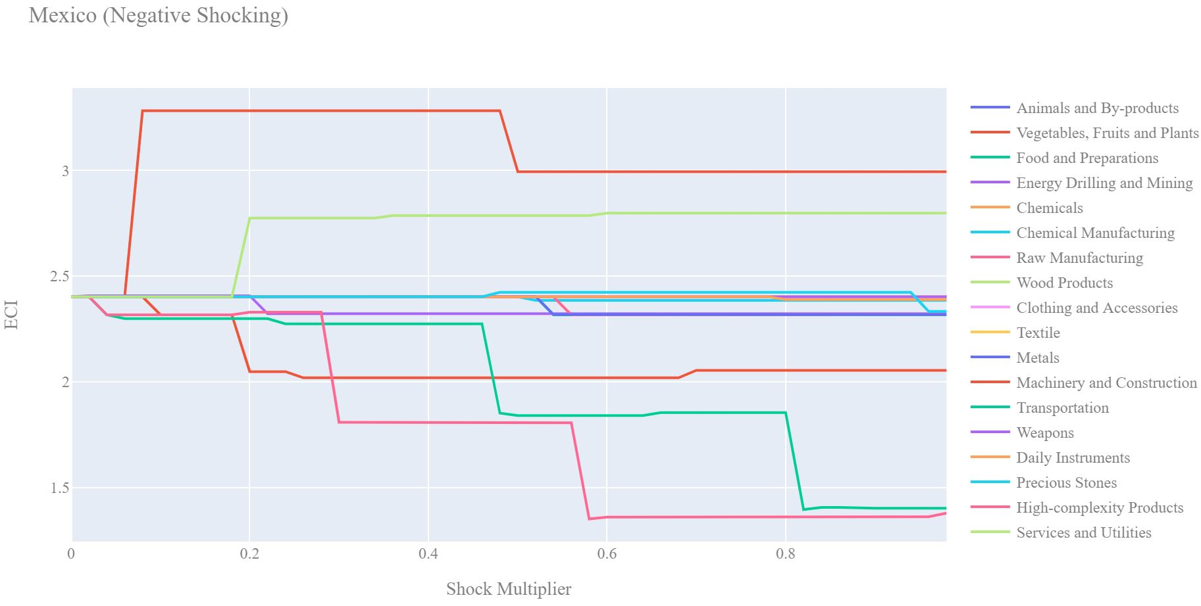
Figure 7b. Decremental ECI Sensitivity for Mexico (2018)

Next, we consider the 2013 ECI Sensitivity graphs (Figures 8a and 8b). We see that in the positive shocking case, the landscape of ECI sensitivity has not altered significantly over the three-year period. Raw Manufacturing, Weapons, Chemical Manufacturing, and Services and Utilities lead to an uptrend in ECI. However, we see that in 2018 Mexico seems to be highly sensitive to increases in Energy Drilling and Mining.

In the 2013 negative shocking case, we see that again Mexico is very sensitive to drawbacks in Energy. Again we see that Mexico is highly insensitive to drawdowns in the majority of its industries. However, unlike the 2018 case, we see quite a bit of sensitivity to Metals.
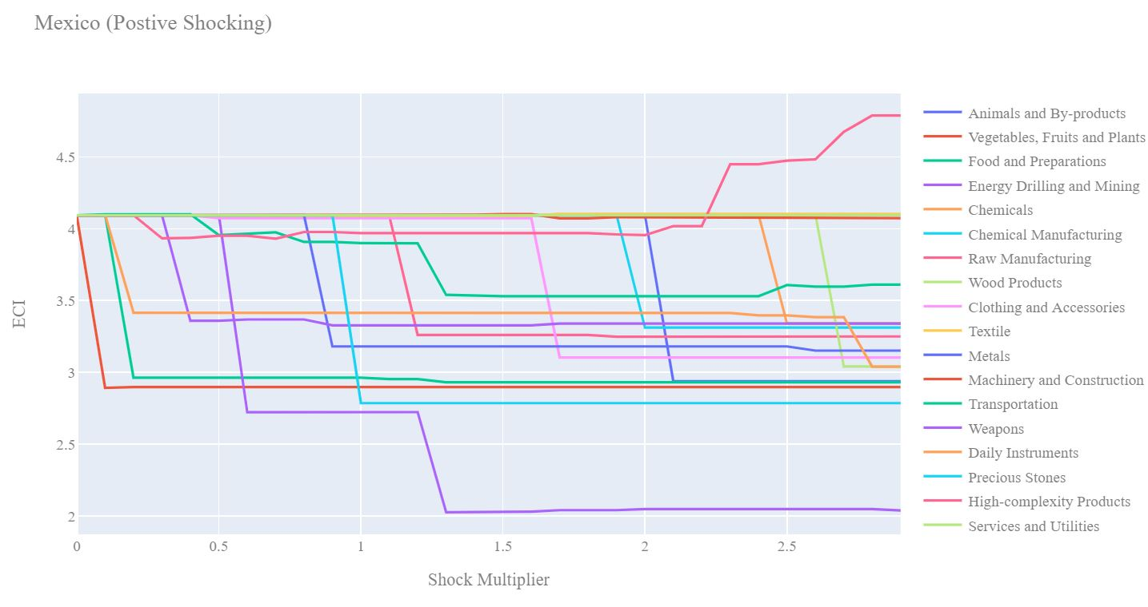
Figure 8a. Incremental ECI Sensitivity for Mexico (2013)

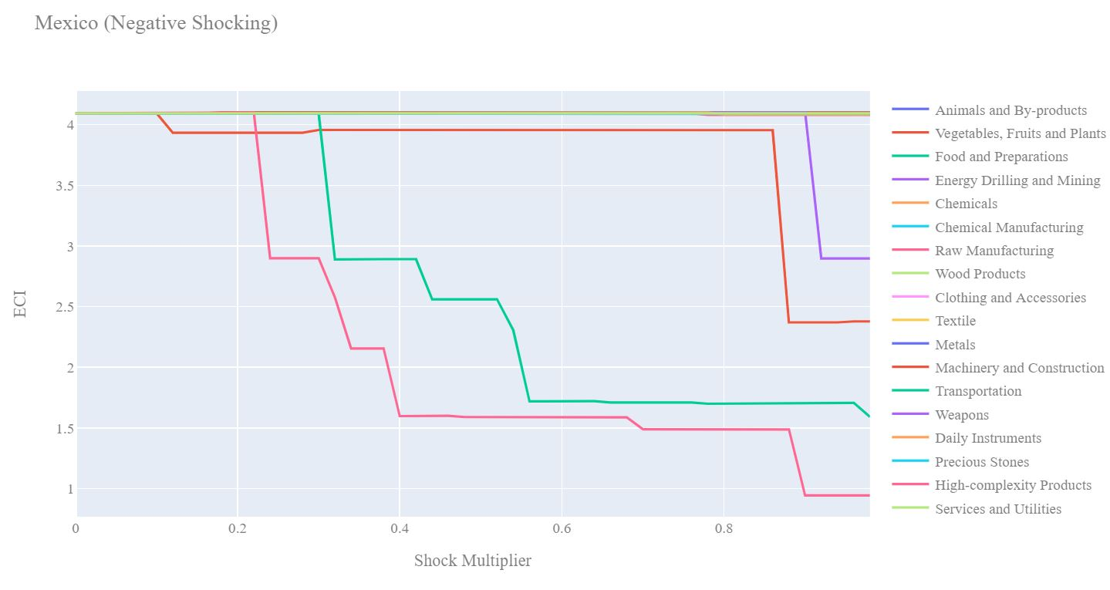
Figure 8b. Decremental ECI Sensitivity for Mexico (2013)

Below we see the SDV sensitivity charts for High Complexity Products (Tables 11 and 12). We see that everything held at current levels results in an SDV that contains 13 positive opportunity gain industries. Increases in the export of High Complexity Products leads to the conversion of many positive opportunity gain industries into negative opportunity fain industries since it would be more beneficial to continue to focus on High Complexity Products and industries related to High Complexity Products.

Considering the Negative SDV sensitivity chart we observe that as exports of High Complexity Products decrease the SDV is not very affected. This is because many other industries already begin with a positive opportunity gain and so the export level of High Complexity products does not significantly affect their potential benefits.

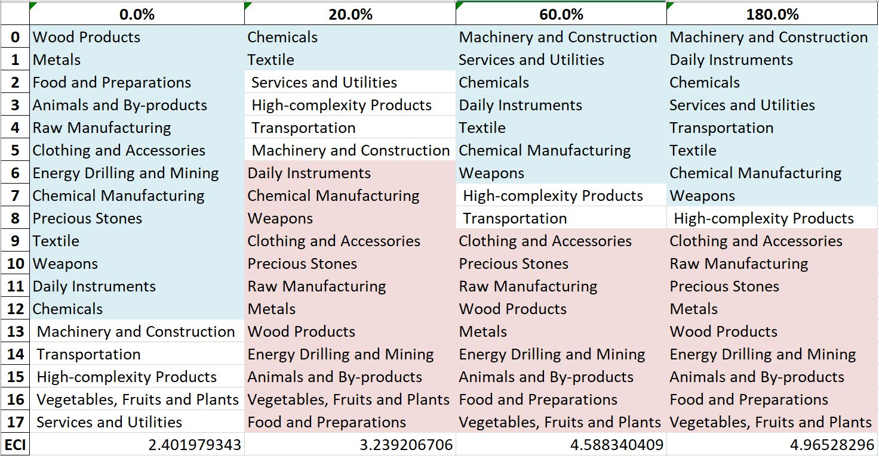
Table 11a. Mexico’s Incremental SDV Sensitivities for High-Complexity Products (2018)

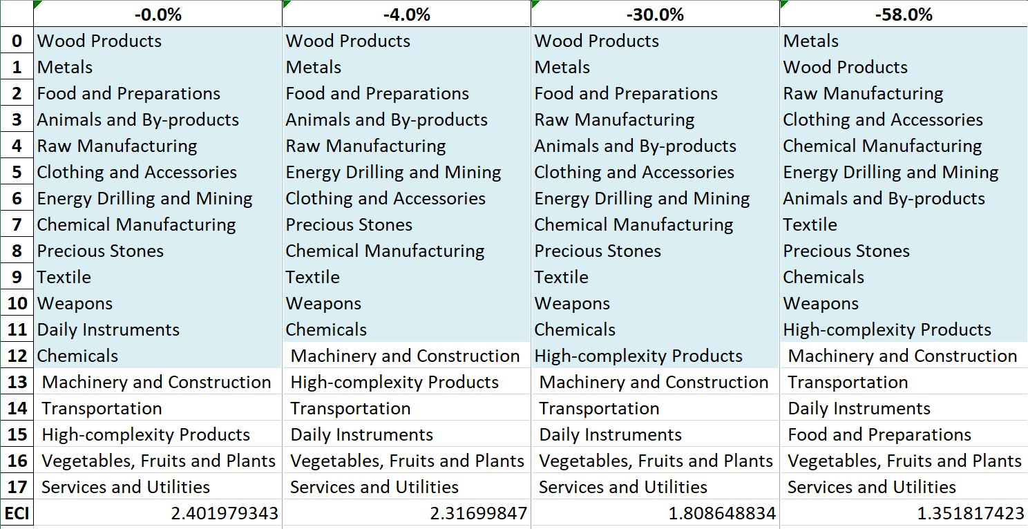
Table 11b. Mexico’s Decremental SDV Sensitivities for High-Complexity Products (2018)

Below we see the SDV sensitivity charts for Food and Preparations. As expected for a fairly developed country, Mexico is not very sensitive to both the positive shocking and negative shocking cases for Food and Preparations. The country's SDV is largely unaffected by this particular industry. We note again that 2018 data is more relevant for the analysis as the country has not been affected by the change of policies due to COVID.
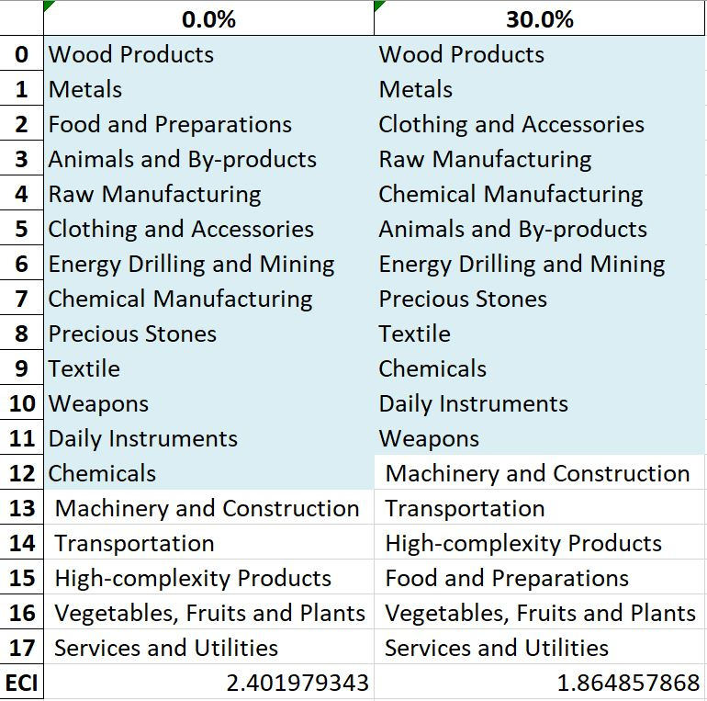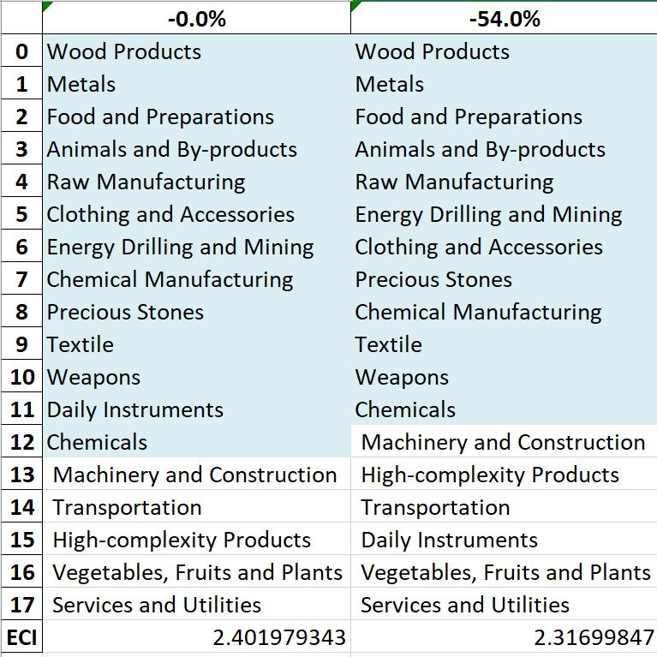
Table 12. Mexico’s Incremental and Decremental SDV Sensitivities for Food and Preparations (2018)

4.4 Contingency Strategy

Decreasing export of each industry in Mexico’s current production space by 60% respectively, we derive the contingency strategies shown below.

Product Names | 0 | 1 | 2
Animal and By-products | Transportation | Machinery and Construction | High-complexity Products
Vegetables, Fruits and Plants | Transportation | Machinery and Construction | High-complexity Products
Food and Preparations | Transportation | Machinery and Construction | High-complexity Products
Energy Drilling and Mining | Transportation | Machinery and Construction | High-complexity Products
Chemicals | Transportation | Machinery and Construction | High-complexity Products
Chemical Manufacturing | Transportation | Machinery and Construction | High-complexity Products
Raw Manufacturing | Transportation | Machinery and Construction | High-complexity Products
Wood Products | Transportation | Machinery and Construction | High-complexity Products
Clothing and Accessories | Transportation | Machinery and Construction | High-complexity Products
Textile | Transportation | Machinery and Construction | High-complexity Products
Metals | Transportation | Machinery and Construction | High-complexity Products
Machinery and Construction | Services and Utilities | Machinery and Construction | Transportation
Transportation | Vegetables, Fruits and Plants | Daily Instruments | Food and Preparations
Weapons | Transportation | Machinery and Construction | High-complexity Products
Daily Instruments | Transportation | Machinery and Construction | High-complexity Products
Precious Stones | Transportation | Machinery and Construction | High-complexity Products
High-complexity Products | Services and Utilities | Vegetables, Fruits and Plants | HDaily Instruments
Services and Utilities | Transportation | Machinery and Construction | High-complexity Products
Table 13a. Mexico’s Contingency Strategy (2013)

Product Names | 0 | 1 | 2
Animal and By-products | Wood Products | Metals | Food and Preparations
Vegetables, Fruits and Plants | Services and Utilities | Daily Instruments | Transportation
Food and Preparations | Wood Products | Metals | Food and Preparations
Energy Drilling and Mining | Wood Products | Metals | Food and Preparations
Chemicals | Wood Products | Metals | Food and Preparations
Chemical Manufacturing | Wood Products | Metals | Food and Preparations
Raw Manufacturing | Wood Products | Metals | Food and Preparations
Wood Products | Wood Products | Metals | Food and Preparations
Clothing and Accessories | Wood Products | Metals | Food and Preparations
Textile | Wood Products | Metals | Food and Preparations
Metals | Wood Products | Metals | Food and Preparations
Machinery and Construction | Wood Products | Metals | Food and Preparations
Transportation | Wood Products | Metals | Raw Manufacturing
Weapons | Wood Products | Metals | Food and Preparations
Daily Instruments | Wood Products | Metals | Food and Preparations
Precious Stones | Wood Products | Metals | Food and Preparations
High-complexity Products | Metals | Wood Products | Raw Manufacturing
Services and Utilities | Wood Products | Food and Preparations | Metals
Table 13b. Mexico’s Contingency Strategy (2018)

5. Macro-level Predictions

5.1 Structural Optimality Index
Indeed, such choice of prioritization has proven to be a significant factor in deciding the economic outcomes of countries. In order to quantitatively evaluate how effective our development strategies are and how deviations from the suggested developmental path will lead to suboptimal growth results, we define the measure – Structural Optimality Index (SOI) – on a country level as the Adjusted R-Square obtained from regressing the country’s realized industry development over the suggested development strategy. Both strategies are quantified in nature, with the realized development represented by increasing export in every major industry group and the suggested development strategy represented by the opportunity gains of developing the corresponding industry groups as calculated in previous sections. The adjusted R-square from the regression thus provides us with a quantified measure of how the development path adopted by the country has fitted with/differed from calculations on a complexity level.

After obtaining this measure for all countries in our database, we further regress countries’ five-year economic growth, which is defined as the percent increase in GDP (USD), over their SOI. Figure 9 illustrates the regression output, which shows a strong positive correlation between countries’ SOI and their five-year GDP growth, significant at the 1% level and achieving an adjusted R² of 4.5%. In other words, the more a country develops as suggested by calculations on a complexity level, the better economic outcomes it achieves.

Table 14: OLS Regression Results
Dep. Variable: GDP | F-Statistic: 5.963
R²: 0.054 | Prob (F-Stat): 0.0163
Adj R²: 0.045 | No. Observations: 106


Figure 9. Regression of Five-Year GDP Growth over SOI (2013-2018)

5.2 SOI of Mexico and Its Implications
Mexico, for instance, stands out among the countries in terms of structural optimality. As the regression in Figure 7 suggests (the red curve represents export increase and the blue curve stands for opportunity gain of the corresponding industry), Mexico demonstrates a high level of correlation with the suggested developmental path, having an adjusted R-square of around -6.1%. Mexico ranks 103rd place among all countries in terms of SOI and has a 5-year GDP growth rate of 21.3% from 2013 to 2018. This is in direct contrast to developed economies such as the United States, where there is a moderate SOI of around 15.7% and a corresponding annual growth rate of 22.1% similar to that of Mexico. Despite such a difference in SOI, Mexico seems to be growing at the same rate as the USA. As has been expressed, this is likely due to other political and economic factors not covered by the SOI index. It can be said that, Mexico’s growth rate would have likely been higher had it followed a more optimal development strategy. For example, larger investment in High Complexity Products would be a positive factor.

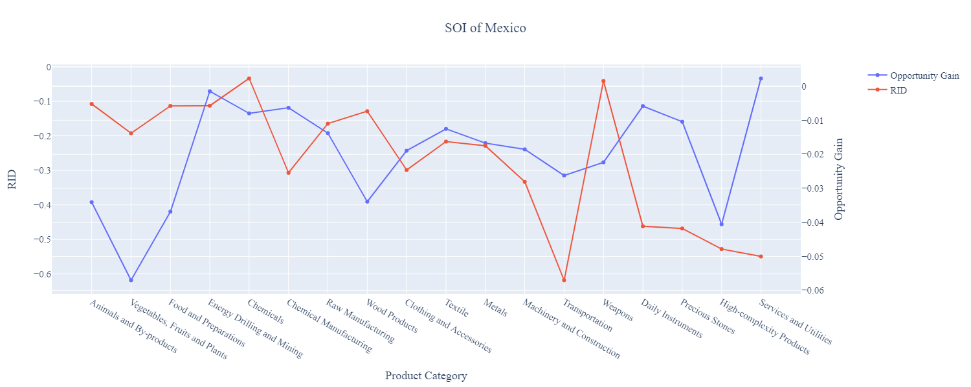
Figure 10a. SOI of Mexico (2009-2014)

For the 2019-2021 years, Mexico has a strong presence in the Weapons industry, which also presents a good opportunity for further investment. It also could consider Energy Drilling and Mining and Precious Metals to improve its growth. Mexico has seen a growth in GDP over those three years of 1.86%, with an average annual growth of 1.53%, compared to 0.5% for the average yearly growth for the five years prior. While Mexico saw an increase in GDP growth compared to 2013-2018, its post-pandemic recovery is notably slower than other compatible economies’. Mexico also ranked in the fourth quartile among all countries in terms of SOI.

Significantly higher than before, its adjusted R-squared value of 0.088 still indicates a low correlation between GDP growth and the implemented development path. Progress is slow on a global scale during this period, but Mexico demonstrates a greater ability to adjust to negative economic shocks by improving SOI and increasing GDP growth than it did between 2013 and 2018.

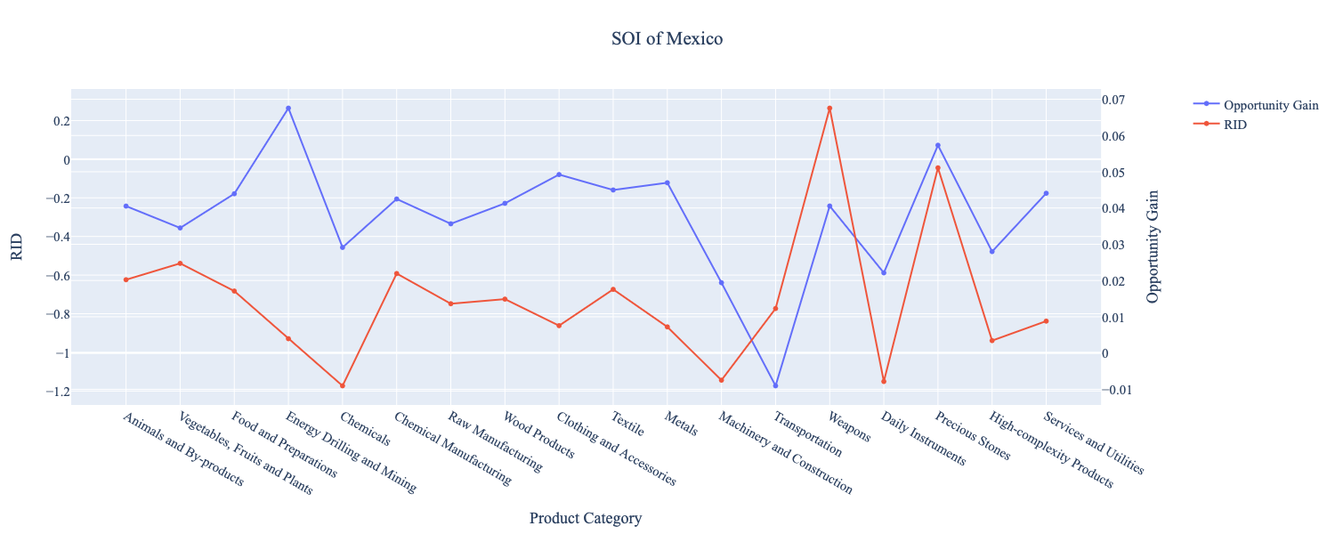
Figure 10b. SOI of Mexico (2019-2021)

6. Concluding Remarks

In conclusion, Mexico has demonstrated a low level of economic growth in terms of annual GDP increase during the period from 2013 to 2018, concurrent with stability in economic complexity as compared with other emerging economies in the world. For 2019-2021, the growth in GDP has increased while its ECI decreased, a trend that varied a lot among its comparable countries or some of the leading economies in the world.

The progress during the first period, we believe, can be partially explained through the analysis of the economic and product complexity structure of Mexico on the industry group level. The product classification system we adopt allows us to measure the realized industry development for various industry groups and to observe that Mexico invested heavily in developing basic industry groups such as Transportation and Services and Utilities in 2018, while its emerging peers and developed economies around the globe have adopted much more complex growth paths that can be potentially too aggressive and poorly-suited. It shifted its focus toward more complex industries in 2021.

Based on our analysis of the opportunity gain and sensitivity analysis of major industry groups for 2013-2018, Mexico can further its gains by prioritizing Daily Instruments and Chemicals. We further note that Mexico has a well-matched development strategy that indicates a particularly high level of structural optimality on the complexity level, having an adjusted R-square of merely -6.1%, compared to 8.8% in 2021. Since a significant positive correlation exists between five-year GDP growth and the structural optimality index of an economy as we define and calculate, Mexico indeed has a nearly optimal growth experience as compared with fast-growing economies both on a regional and global scales and has the potential to further its economic gains through industrial structure optimization as suggested in the paper.

During the second examined period from 2019 to 2021, Mexico performed much stronger than before and compared to other countries, particularly Germany. We also note that Mexico has changed its investment strategy in the sectors identified earlier, still leaving some room for strategic improvement in Energy Drilling and Precious, Metals, and Chemicals industries, for instance. It did invest in industries that contributed significantly to its advancements, such as Weapons. The ECI suggests that greater growth could have been achieved through increased export growth in the Textile and Precious Stones industries while being most sensitive to the impact of High-Complexity Products. With the revised focus, Mexico has further potential to advance its economic growth to improve its position among other countries to continue its post-pandemic recovery.

References

Hausmann, R., Hidalgo, C., Bustos, S., Coscia, M., Chung, S., Jimenez, J., Simoes, A. and Yıldırım, M. (2007). The Atlas of Economic Complexity. [online] Atlas.cid.harvard.edu. Available at: http://atlas.cid.harvard.edu/.

Balassa, B., “The Purchasing Power Parity Doctrine - A Reapprais- al,” Journal of Political Economy 72, 584-596 (1964).

Feenstra, R.; Lipsey, R.; Deng, H.; Ma, A. & Mo, H. “World Trade Flows: 1962-2000” NBER working paper 11040. National Bureau of Economic Research, Cambridge MA (2005).

United Nations Commodity Trade Statistics Database (http://comtrade.un.org/db/), accessed in August 2019.

The World Economic Forum, “The global competitiveness report,” (various years).

Barro, R. & Lee, J-W. “A New Data Set of Educational Attainment in the World, 1950-2010,” NBER Working Paper No. 1590 (2010).

Kaufmann, D. & Kraay, A. “Governance Indicators: Where Are We, Where Should We Be Going?” Policy Research Working Paper 4370. Washington, DC: World Bank (2008).

Hanushek, E.A. & Woessmann, L. “The Role of Cognitive Skills in Economic Development,” Journal of Economic Literature 46(3), 607- 668 (2008).

